1.
Draw a labeled diagram of an ATX motherboard and mark at least 8 different slots and ports (such as RAM slots, PCIe slots, SATA ports, USB headers, CPU socket, power connector, etc.).
ANS:

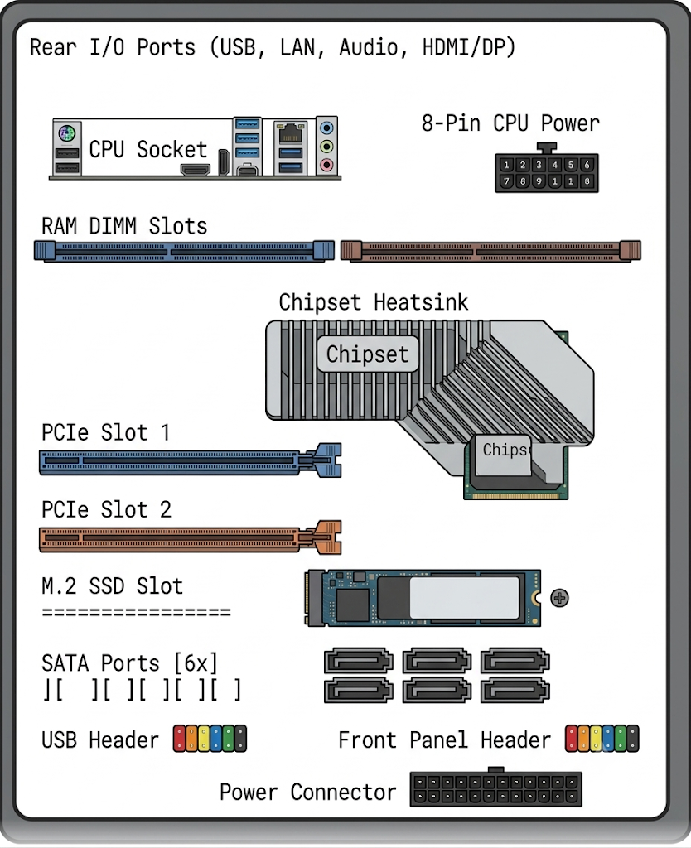

2.Research and list 3 popular CPU socket types (for example: LGA1151, AM4, LGA1200) and name one compatible CPU model for each.
ANS:

CPU socket type compatible CPU model
------------------------------------------------
LGA1151 intel core i7-9700K
AM4 AMD Ryzen 5 5600X
LGA1200 intel core i5-10400

3.
Explain in your own words the primary functions of the CPU and the chipset on a motherboard, and describe how they work together when you open a music app like Spotify.

ANS:
CPU:executes instructions and runs programs.
chipset:controls communication between the cpu and other hardware.
together work in spotify:the cpu processes spotify instruction while the chipset moves data between storage,memory,and other device so the app can open and play music.

4.Find a clear photo of a real motherboard (from the internet or your own device), and identify at least 5 different ports or slots by circling them and labeling each one.

ANS:
